2 - Testing throughout the Software Development Lifecycle

## > SDLC Models

There are two different SDLC models:

* Sequential development models
* Iterative and incremental development models

### Sequential models

A sequential development model describes the software development process as a linear, sequential flow of activities. This means that any phase in the development process should **begin** when the **previous** phase is **complete**.

#### Waterfall

Waterfall is a sequential development model where the development activities are completed one after another. In this model, test activities only occur after all other development activities have been completed.

In this model, **Early testing** is **not possible.**

#### V-model

Follows the same process as Waterfall but as a difference, the V-model integrates the test process throughout the development process.

This model does **implement** the principle of **early testing.**

### Iterative and Incremental models

Incremental development builds and tests a system in pieces, which means that the software’s features grow incrementally.  
  
Iterative development occurs when groups of features are built and tested together in a series of cycles. Iterations may involve changes to features developed in earlier iterations, along with changes in project scope.

Includes:

* Rational Unified Process
* Scrum
* Kanban
* Spiral

## > SDLC Models in Context

SDLC models **must** be **selected** and **adapted** to the context of project and product characteristics, not the other way around.

SDLC models themselves can be **combined**.

Reasons to adapt a SDLC model to the context of a project can be:

* Complexity of the project
* The type of product being built
* The timezone of different members of the team
* Short time to deliver a product to the market

## > Test Levels

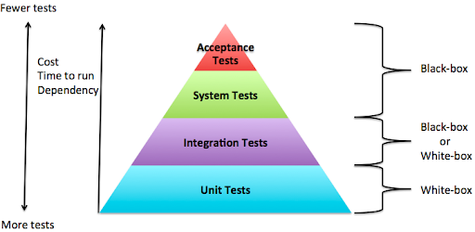

Tests Levels:

* Unit Test
* Integration Test
* System Test
* Acceptance Test

## > Test Types

Test Types are groups of testing activities

* **Functional**. Code always needs to be executed
* **Non Functional**. Includes acceptance, performance or security tests
* **White Box**. Code can or can't be executed
* **Change-Related**. Includes Confirmation and Regression tests

Other tests types are:

**Confirmation Testing** - It just validates that a bug is fixed. Checks that a previous failed test case is now passing.

**Regression Testing** - Validation of side effects. Verify that changes have not affected any other functionality that was working correctly.

**Change Related Testing** - Equal to: **Confirmation** tests **+** **Regression** tests.

**Smoke Testing** - It's like taking its pulse. It helps to validate that the product is ready to launch a regression.

**Sanity Testing** - Similar to smoke but this is focused on a specific feature or module of the system, in other words, **sanity is a subset of regression testing**.

## > Test Types and Test Levels

It is possible to perform any of the test types mentioned above at any test level

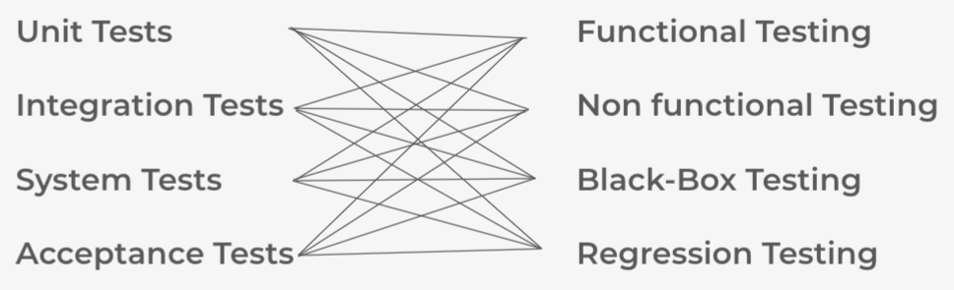

## > Maintenance Testing

Takes place on a system which is in operation in the live environment.  
  
Once deployed to production environments, software and systems need to be maintained.

Maintenance is also needed to preserve or improve non-functional quality characteristics of the component or system over its lifetime, especially performance efficiency, compatibility, reliability, security and portability.

### Triggers for Maintenance

We can classify the triggers for maintenance as follows:

* Modification, such as enhancements, corrective and emergency changes, changes of the operational environment.
* Migration, such as moving from one platform to another, or when data is being transferred to the system being maintained.